**Bahria University, Lahore Campus**

Department of Computer Sciences

Lab Journal 01

**(Spring 2022)**

|  |  |  |
| --- | --- | --- |
| Course: | **Data Communication & Networks Lab** | Date: |
| Course Code: | CEL - 222 | Max Marks: 10 |
| Faculty’s Name: |  | Lab Engineer: Fakhra Batool |

Name: **ALI HASSAN**  Enroll No: **03-135211-005**

Objective(s) :

To explore some basic concepts related to networking devices and cables. Construction of Ethernet cable RJ45.

## Lab Tasks :

**Task 1: Make a LAN Cable using RJ45. (Procedure)**

1. Use your cable strippers at about 1-2 inches from the end of the cable to remove the outer jacket.

## Untwist the twisted pair wires all the way back to the jacket.

1. Align the untwisted wires in the order necessary for your needs.

## Cut the extra wire.

1. Push the remaining wires into the RJ45 head.

## Double-check that the wires are all the way up into the gold pins of the head and made it up in the proper order.

1. Push the head into the open space of the crimping tool and squeeze it closed, hard.

## Open the crimping tool and remove your newly-crimped Ethernet connector.

1. Repeat the crimping process on the other side of the cable if you're making a completely new cable.

## Plug one end of the cable into the tan, two-port end of the cable tester, and the other end into the other part of the tester with the graphic display window.

1. Plug your Ethernet cable in.

**Task 2: Identify differences between Switches and Hubs.**

## SWITCHES:

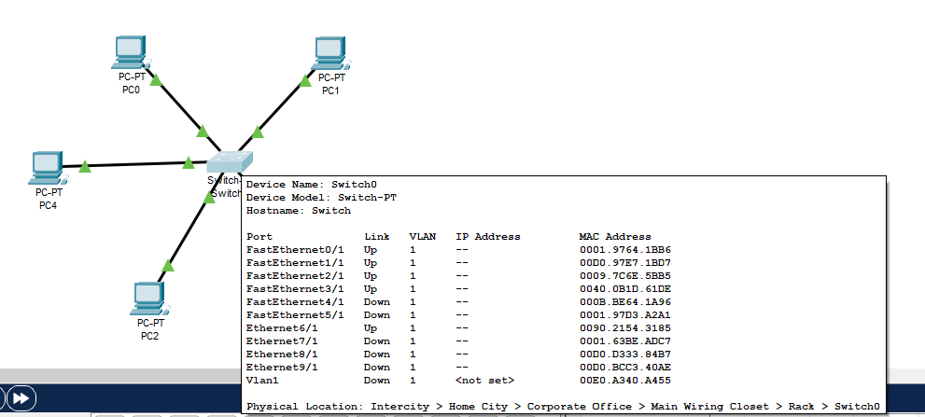

**HUBS:**

## 

**Task 3: Which OSI layer is the following? Router, Hub, Switch**

## Router:

1. Physical layer
2. Network layer
3. Data link layer

**Switch:**

## Datalink layer

1. Physical layer

**Hub:**

## Physical layer

## Task 4: What is a Transmission media? List the difference between Straight and Crossover Cables.

**Transmission Media:**

A transmission medium is a device or material that can mediate the transfer of signals for telecommunication purposes. Signals are usually placed on a wave of some type that is appropriate for the medium.

## Difference between Straight and Crossover Cables

Straight-through and crossover Ethernet connections are available. The most popular variety is the straight-through, which is used to connect PCs to hubs or switches. They are most likely what you will discover when purchasing a patch cable from your local computer store. Crossover connections are more widely utilized to link two computers and are thus more difficult to come by than straight-through cables.

**Lab Grading Sheet :**

|  |  |  |  |
| --- | --- | --- | --- |
| **Task** | **Max Marks** | **Obtained Marks** | **Comments(*if any*)** |
| 1. | 10 |  |  |
| 2. | 10 |  |  |
| 3. | 10 |  |  |
| 4. | 10 |  |  |
| **Total** | **40** |  | **Signature** |

**Note : Attempt all tasks and get them checked by your Lab Instructor.**

# Lab 01: Introduction to Networking Devices

## ****Objective****(s):

To explore some basic concepts related to networking devices and cables. Construction of Ethernet cable RJ45.

## Tool(s) used:

Network Interface Cards

Hubs

Switches

Routers

Ethernet Cable

Straight Cable

Crossover Cable

RJ45 Cable

Crimping Tool

Connectors

## NETWORK DEVICES

All networks are made up of basic hardware building blocks to interconnect network nodes, such as Network Interface Cards (NICs), Hubs, Switches, and Routers etc. These devices also need cables to connect them. In this Lab we will understand these devices.

## NIC (Network Interface Card)

A network interface controller is a computer hardware component that connects a computer to a computer network. The controller may also be referred to as a network adapter, or a LAN adapter. Also known as a network interface card, network card or LAN card.

It is both an OSI layer 1 (physical layer) and layer 2 (data link layer) device, as it provides physical access to a networking medium and provides a low-level addressing system through the use of MAC addresses. It allows users to connect to each other either by using cables or wirelessly.

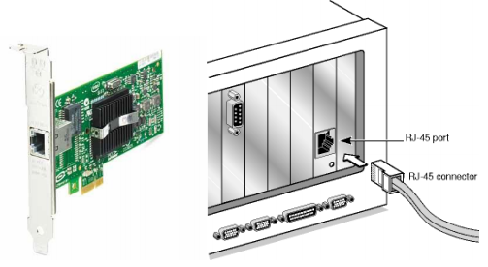

## Hub

An Ethernet hub, active hub, network hub, repeater hub or hub is a device for connecting multiple twisted pair or fiber optic Ethernet devices together and making them act as a single network segment. Hub works at the physical layer (layer 1) of the OSI model. The device is a form of multiport repeater. Repeater hubs also participate in collision detection, forwarding a jam signal to all ports if it detects a collision.

A network hub is a fairly unsophisticated broadcast device. Hubs do not manage any of the traffic that comes through them, and any packet entering any port is regenerated and broadcast out on all other ports.

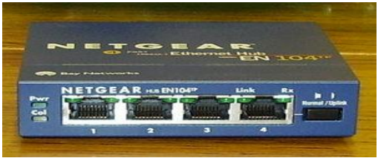

## Switch (LAN Switch)

Switches are devices capable of creating temporary connections between two or more devices linked to the switch. It acts just like hub but has advanced features for network optimization &better security. Switch works at the Data Link layer (layer 2) of the OSI model. The work a switch does is called switching.

Switches that additionally process data at the network layer (layer 3 and above) are often referred to as Layer 3 switches or multilayer switches. The main purpose of both Switch & Hub is to extend the size of network.

A switch uses an internal address table to route incoming data frames via the port associated with their destination MAC address. Some switches are capable of routing based on IP addresses.

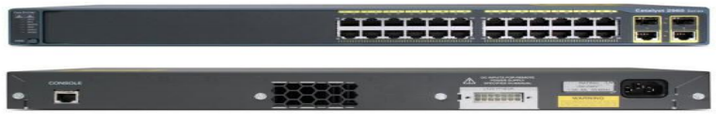

## Router

A router is a device in computer networking that forwards data packets to their destinations, based on their addresses. The work a router does is called routing, which is somewhat like switching, but a router is different from a switch. The latter is simply a device to connect machines to form a LAN. Routers work at the Network layer (layer 3) of the OSI model. Their main purpose is to allow communication between different network.

A router is connected to at least two networks, commonly two LANs or WANs or a LAN and its ISP's network. Routers are located at gateways, the places where two or more networks connect, and are the critical device that keeps data flowing between networks and keeps the networks connected to the Internet. When data is sent between locations on one network or from one network to a second network the data is always seen and directed to the correct location by the router. The router accomplishes this by using headers and forwarding tables to determine the best path for forwarding the data packets, and they also use protocols such as ICMP to communicate with each other and configure the best route between any two hosts. The Internet itself is a global network connecting millions of computers and smaller networks. The

[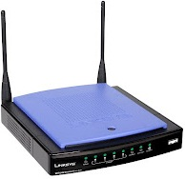](http://2.bp.blogspot.com/-k58f6Wxf-G0/UF74srQf7fI/AAAAAAAAANE/jrfWy9fSfOc/s1600/router.jpg)

## TRANSMISSION MEDIA

In order for the communication to take place, cables play important role. Cable is the medium through which information usually moves from one network device to another. There are several types of cable which are commonly used with LANs. The type of cable chosen for a network is related to the network's topology, protocol, and size.

There are various types of cables used in networks as follows:

**Ethernet Cable**

An Ethernet cable, also called a category 5 (Cat 5) cable, carries the broadband signals between your modem, router, computer, and other wired Internet-capable devices. Ethernet cable has eight wires. Its shown along with its color combination.

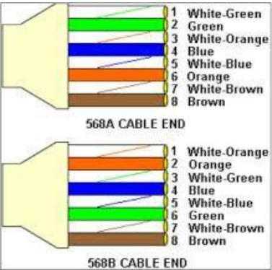

## Straight Cable

You usually use straight cable to connect different type of devices. This type of cable will be used most of the time and can be used to:

1. Connect a computer to a switch/hub's normal port.
2. Connect a computer to a cable/DSL modem's LAN port.
3. Connect a router's WAN port to a cable/DSL modem's LAN port.
4. Connect a router's LAN port to a switch/hub's uplink port (normally used for expanding network).
5. Connect 2 switches/hubs with one of the switch/hub using an uplink port and the other one using normal port.

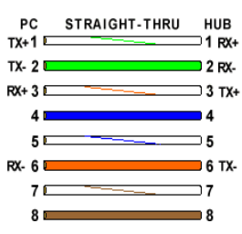

**Crossover Cable**

Sometimes you will use crossover cable, it's usually used to **connect same type of devices**. A crossover cable can be used to:

1. Connect 2 computers directly.
2. Connect a router's LAN port to a switch/hub's normal port. (normally used for expanding network)
3. Connect 2 switches/hubs by using normal port in both switches/hubs.

